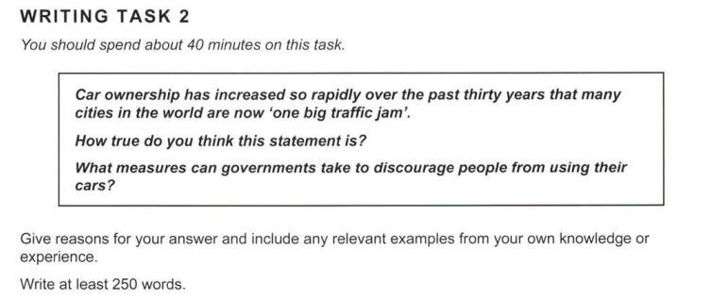

Advancements in the automobile industry have led to a large-scale use of cars, which have been the central cause of congestion in innumerable cities around the world. In a lot of these cities, the roads and associated infrastructure have not developed in the same way as the cars, and reconstructing them in a car-centric way could prove to be problematic. In my opinion, the given statement is true of many metropolitan areas around the world. So, how bad is this problem, and what can we do to alleviate it?

In Bengaluru, my home city, the commute between any two areas that seem close on a map can sometimes take hours. Our roads have no provisions for bicycle lanes, and the populace has increasingly moved towards using cars as the sole mode of transport. There have been no real efforts to change the way we travel, and the traffic jams that plague the economically important areas of the city pose huge threats to the city’s reputation as the ‘Silicon City of India.’ Multinational corporations that have constructed offices in Bengaluru are strongly considering moving to a different area if the situation is not ameliorated. Coupled with the environmental concerns of fast-deteriorating air quality in and around the city, these economic concerns demand government action.

What can the government do to address this issue? Public modes of transport like buses and metros could be subsidised, and roads could be modified to accommodate and encourage cyclists, in areas where possible. Widening roads has proven to be a band-aid solution, which lasts as long as traffic does not increase – for a bustling, growing city like Bengaluru, it would be unreasonable to expect this to work. More money must be put into studies that look into effective alternatives that address prevailing issues.

For cities that have expanded in an unplanned manner, solving congestion would take more time and resources, and would be vital for all aspects of their progress. Hence, it would be in the government’s best interests to address these issues in the methods described above.